1. Introduction
Conquer the Seas is a turn-based strategy game in which both players select moves simultaneously. The game puts two players against each other as they maneuver underwater ships to destroy oncoming enemies and collect resources, winning when the other player's ships have been destroyed.

1.1 Purpose
This Software Requirements Specification (SRS) is a description of all functions and specifications of Conquer the Seas. It gives a comprehensive look at all aspects of the game. This document is based on the IEEE 830 Standard.

1.2 Scope
This section outlines the function and goals of this project. It gives a sense of what problem this software sets out to solve or the market it seeks to occupy.
This product is a single- and multi-player game with a nautical theme. It can be played against AI controlled opponents or other humans over a network (either internet or local network). The goal of this is to provide a fun and complex game that can entertain on several plays. It will contain a resource system, multiple paths for upgrading of units, and complex strategies that will develop over the lifespan of the game.

1.3 Definitions, acronyms, abbreviations
This section outlines the terminology and acronyms used throughout this document.

1.3.1 Definitions
- Client: The local instance of the game GUI on a player's machine.
- Server: The unique hosted game to which other clients connect. The server is hosted on the machine of one of the players.
- Player: The user playing the game using the client GUI.
- Host: The player who is running the server in addition to running their client. This is the player "hosting" the multiplayer game.
- Action: A command that players can choose to issue during their turn.
- Kick: To remove a player from the multiplayer lobby and close the connection to their computer.

1.3.2 Acronyms
Acronym | Definition
AI | Artificial Intelligence
(G)UI | (Graphical) User Interface
IEEE | Institute of Electrical and Electronics Engineers
LAN | Local Area Network
SRS | Software Requirements Specification
TCP | Transfer Control Protocol
UML | Unified Modeling Language

1.4 References
- IEEE Recommended Practice for Software Requirements Specifications. New York: Institute of Electrical and Electronics Engineers, 1998.

1.5 Overview
Chapter 2 provides a description of the game itself, with textual explanations of the possible interactions a player can have with the game, such as actions, victory conditions, and basic gameplay. Chapter 3 contains annotated screenshots and use cases to detail all processes explained in Chapter 2.

2. Overall Description
This section describes the game scope and functionality. The subsections below outline an overview of the product, the available functions, associated risks and solutions, user characteristics, and apportioning of requirements.

2.1 Product Overview
This section is a summary of the software and its functions.
This product will be a complete single- and multi-player game. It will have functionality for the saving and loading of games, for networked multiplayer from different machines, and for single player versus a computer controlled player (or players) of different difficulties. The game features customizable units with multiple upgrade paths, allowing for many unique combinations which gives a large amount of replayability to even the single player game.
It will use a package of external libraries for game design called pyGame. Other resources like graphics will be created by the LifDoff team. Multiple GUIs will be available throughout the game for players to interact with:
- The Main Menu screen will be displayed as soon as the game application is launched. Several options will be available: New Game, Load Game, Options, Credits, and Exit.
- The Multiplayer Lobby screen will be displayed after the Join Multiplayer or Host Multiplayer options are chosen from the Main Menu. In the Multiplayer Lobby, current players will be displayed, as will a chat box for players to talk to one another before the game begins.
- The Game Screen is the main view for each player once they have entered a game. This screen shows both player's units, along with the game board and current statistics. It also has buttons to open the Shop and Upgrade screens, and a button for the Pause Menu.
- In-Game Views are the multiple screens accessed from within the Game Screen:
  - The Shop Screen is accessed from the Game Screen or from the Upgrades Screen. This allows players to purchase new offensive units to send at the opposing players using the money they have collected. Players can also upgrade the units they have already purchased.
  - The Upgrades Screen is accessed from the Game Screen or the Shop Screen. This is the screen where players spend the experience points they have accrued on upgrades for their three defensive ships.
  - The Pause Menu is accessed from the Game Screen. It has options for adjusting sound settings, opening help, and saving or quitting the current game.
Because Conquer the Seas will be written in Python 2.7, this version or a compatible version of Python must be installed on all machines running the game. Conquer the Seas will be an entirely stand-alone game that will not require any resources besides Python on the machine it runs on.

2.2 Product Functions
This section outlines the different functions of the Conquer the Seas software. Main functions are the overall objectives of the software, and user functions are the actions users may take while inside one of the main functions.
- Main Functions:
  - Host a game
  - Play a game
- User Functions:
  - Host multiplayer
    - Set number of players
    - Add AI players
    - Kick players
    - Change number of players
  - Join multiplayer
  - Start a single player game
  - Load game
  - Chat in multiplayer lobby
  - Select actions
  - Complete turn
  - Save game
  - Exit game

2.2.1 Use Cases

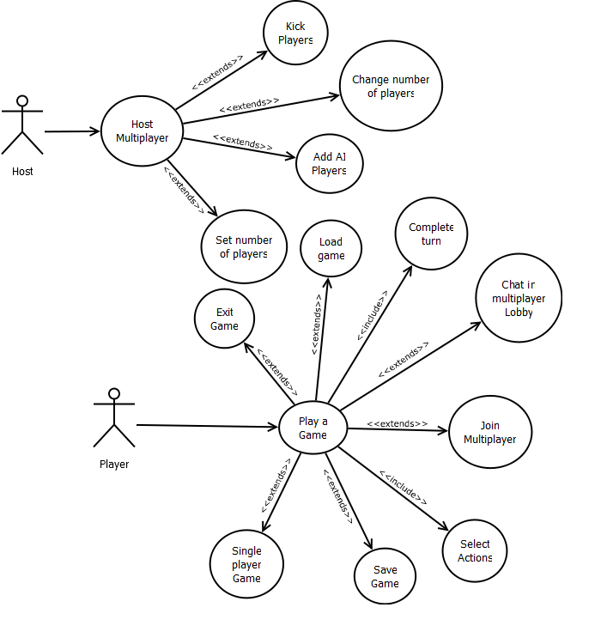

2.3 User Characteristics
This section outlines the different goals, features, and interface expectations of different types of users.
User | Specific Goals | Features | Interface Expectations
Casual Gamer | Have fun during first time playing game | Easy to learn | Intuitive even for inexperienced gamer
Moderate Gamer | Have fun quickly, enough depth to entertain on multiple plays | Not too difficult to learn, enough of a learning curve to make experience valuable | Intuitive, could be complicated if it is similar to other games of the same style
Intense Gamer | Lots of strategy, many levels of depth to learn | Lots of features, experienced player can beat inexperienced player almost every time | Intuitive, offers hotkeys for easier and quicker pace, can be as complicated as necessary
Server Host | Can easily set up server, little to no options to configure | Easy to set up, lack of unnecessary or overly complicated features | Simple interface

2.4 Constraints
This section outlines the constraints placed upon this software. It details individual constraints and the solutions that must be taken to prevent them from negatively impacting the software.
Obviously, hardware limits certain features of the game. The game must run in a small enough amount of RAM that most computers can play it with no decrease in functionality. This means that the number of units on the screen may need to be limited to stay at an optimal level of performance.
Because players will be playing from their own unique machines, steps must be taken to ensure stable (or at least predictable) performance when outside factors interfere with gameplay. Turns will be time-limited, so that if a player is taking too long, other players will not have to suffer indefinitely. Also, if a player disconnects due to loss of power or network issues, the game can be restored from a temporary save that will be written periodically without player interaction.
Player skill and game familiarity must be taken into account. As developers, the game will be incredibly familiar, but a player who has never seen the game before needs to be able to quickly pick up and understand the game without too much help.

2.5 Assumptions and Dependencies
This section details the assumptions the LifDoff team will make in regards to the users and machines that are running the software in addition to the necessary dependencies for successful execution.
It is assumed that all machines have Python 2.7, as this is necessary for the game to run. It is also assumed that any users that wish to engage in a multi-player game are connected to the internet or a local network. It is also necessary that each machine has the ability to connect to or host a server, and thus the network cannot be blocked by a firewall that restricts the ability of the Conquer the Seas software to communicate with a remote server or client.

2.6 Apportioning of Requirements
This section details the features that may not make it into the Conquer the Seas software. These features may be delayed because of a lack of time or because of a lack of experience from the development team.
ID | TITLE | DESCRIPTION | DELAY REASON | WHEN
1 | Multiple Upgrade Trees (per ship) | Each ship could have 3 possible upgrade trees resulting in 9 unique ships, this can be reduced to one per ship | Run out of time | Additional 2 weeks
2 | Screen Transitions | Screen transitions between different menus (main menu background scaling down to be the actual background of the game, etc) | Inexperienced development team | Additional 1 week
3 | >15 Items | Having a large number of items might be unrealistic | Could be unrealistic to expect so many items, inexperienced development team | Additional 2 weeks

2.7 Risk Management
This section outlines the risks this project will face and details their impact, probability, and exposure. It also describes the risk control methods that will be used to account for these risks.

2.7.1 Risk Assessment
ID | Title | Description | Probability | Impact
1 | PyGame library lacks functionality | PyGame library could not have methods or modules that are necessary for our game | High | High - the cost of impact would be having to change or rewrite features incompatible with PyGame libraries
2 | AI Issues | The AI player for single player could be too strong/too weak | Medium | Medium - imbalanced AI would not be game-breaking but would make it much less fun for single player.
3 | Randomly generated terrain is unfair | Each player has randomly generated terrain - if it isn't fair, one player could be at a significant disadvantage | Medium | Medium - this would make the game much less fun
4 | Difficult for users to understand interface | The game is too difficult for new players to pick up and play without having lots of problems | Low | Medium - this could severely deter one portion of the userbase from enjoying this product

The risks associated with this project are not too major, even though some have higher probabilities of occurring. The chance of PyGame not having some functionality Conquer the Seas requires is very likely. The chance of unfair AI or unfair randomly generated terrain are moderately likely, and will need to be dealt with in a way that the leverage shows it is worth it. The interface being difficult for new users to understand is not something that is likely to happen, so making large changes to accommodate for this may not be worth it.

2.7.2 Risk Control
ID | Type | Leverage | Solution Summary
1 | Assume | 5 (worth it) | Plan for the fact that adjustments will have to be made to compensate for incompatibilities or missing features from PyGame
2 | Transfer | 2 (worth it) | Make AI too weak and make it stronger as time permits
3 | Assume | 2 (worth it) | Develop a metric to judge impact of terrain, if two random terrains have very different impacts, re-generate them
4 | Avoid | 3 (worth it) | Try to avoid this all together by erring on the side of a simplistic design, and then adding more complex features as deemed possible
The risks involved are not extremely dangerous. The PyGame library lacking functionality seems like a large problem, but because we are only using its libraries for some features, lacking features is to be expected. We will be able to easily supplement any missing features with those of our own. AI issues only requires maintaining a weak AI and making it stronger until it reaches a fair level of intelligence. Randomly generated terrain can be unfair because of the nature of randomness, but it can be assumed and compensated for by regenerating terrains that have different levels of impact. A complicated interface is a risk that is only partially controllable, as the skill of individuals playing the game cannot always be accurately judged. For all four risks, the leverage shows that it will be worth it to use the given solution.

